Table of Contents

1. Version Control 2

2. Flow Diagrams 3

3. Folder Structure 5

4. Pre-Tasks 6

5. Pruning 6

5.1 Logic for pruning 6

5.2 List of tables to be Pruned using Siebel EIM 7

5.3 List of tables to be Pruned using truncate 8

6 Masking 9

6.1 Logic for Masking 9

6.2 List of Attributes to be Masked 11

7 Post-Tasks 16

8 Jenkins 16

8.1 Global Parameters 16

8.2 Global Credentials 17

## Version Control

|  |  |  |
| --- | --- | --- |
| Version | Description | Update by |
| 1.0 | First draft | Ranjitha Srinidhi |
| 1.1 | Second draft | Nageshwar |
| 1.2 | Third draft | Nageshwar |

## Flow Diagrams

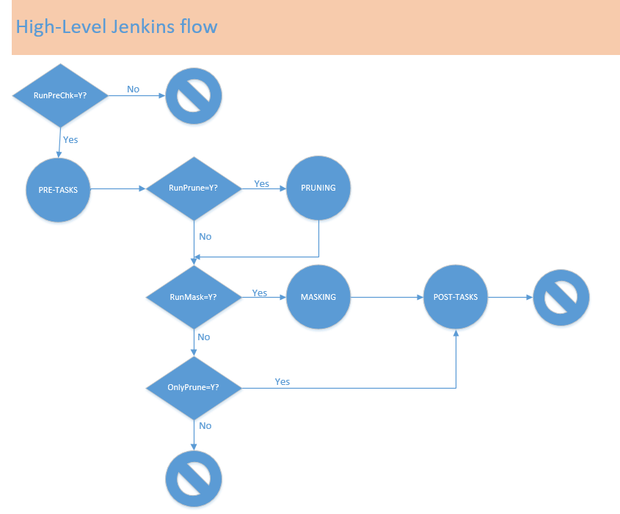

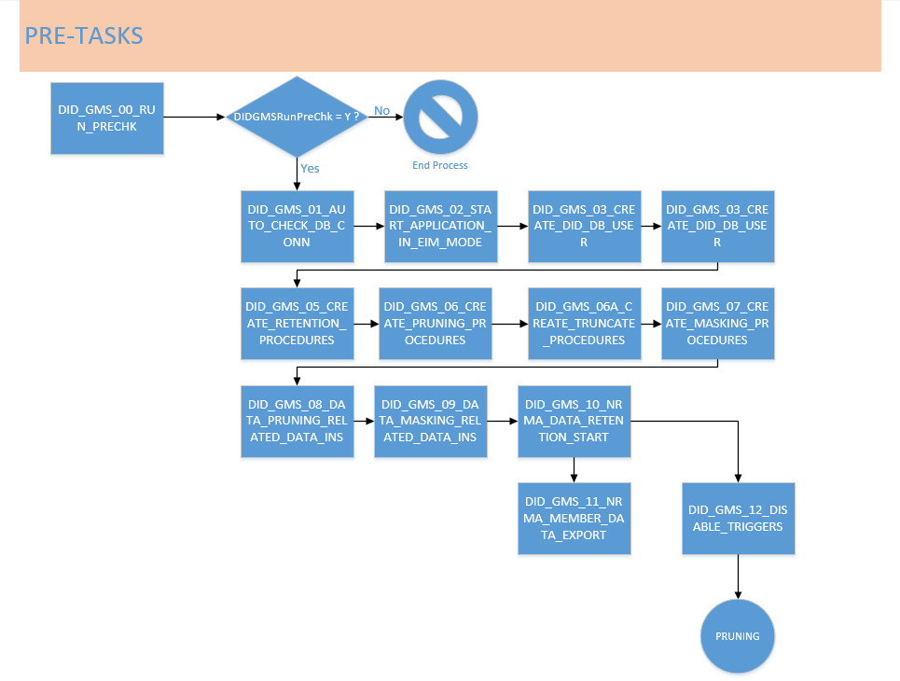

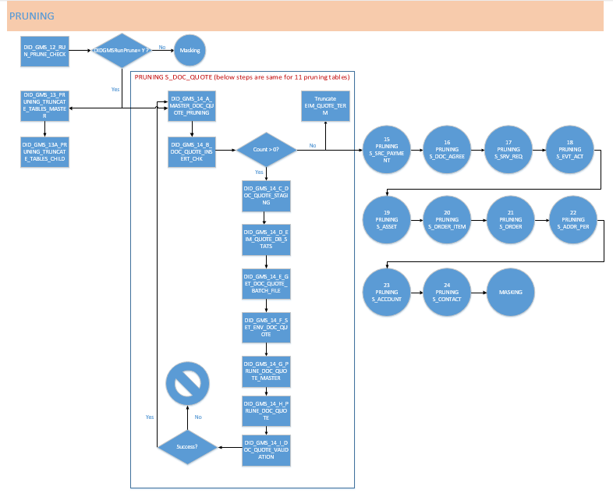

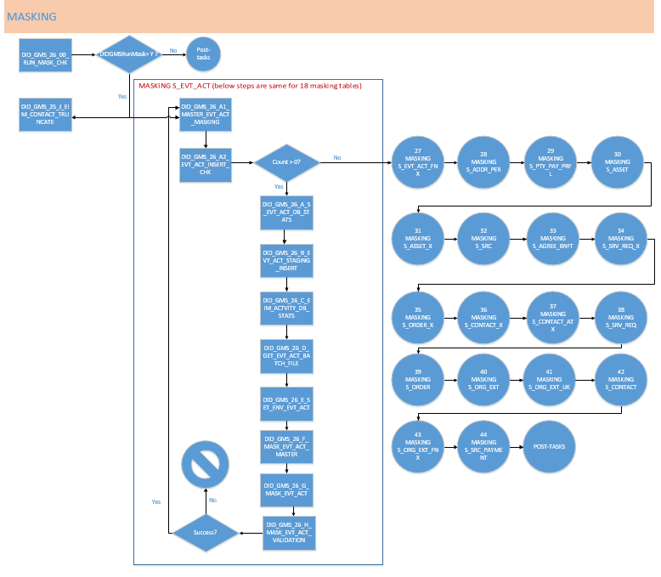

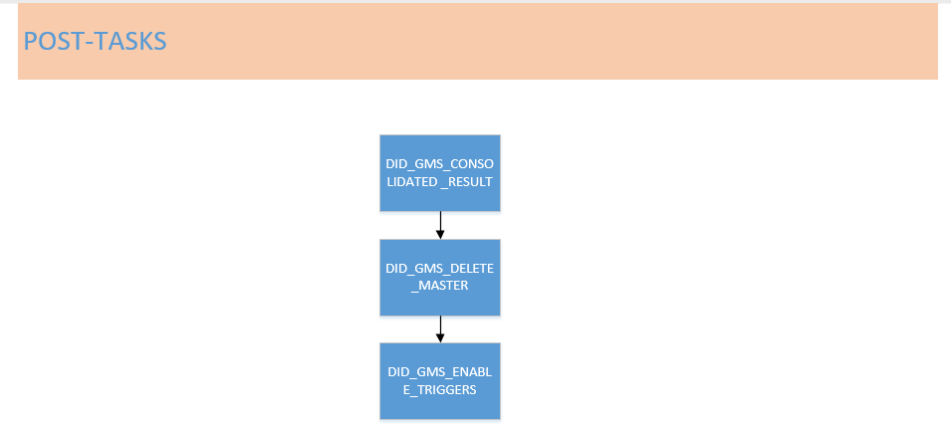

## Folder Structure

All the code required to Prune and Mask should be placed in the **INNOVACX/GMS** folder**.**

|  |  |
| --- | --- |
| Folder Name | Purpose |
| SCRIPTS | All the .sh files are placed in this folder |
| LOG | All the .log files are placed in this folder |
| DATA | All the .csv files are placed in this folder |
| SQL | All the .sql files are placed in this folder |
| CTL_FILES | All the .ctl (sqlldr utility) files are placed in this folder |

## Pre-Tasks

Jobs for pre-task gets executed only when ‘DIDGMSRunPreChk’ Jenkins global variable is set to ‘Y’.

As a pre-requisite,

* Folders attached in the ‘Operational guide’ should be placed at the appropriate location
* OS level access, DB level access and Jenkins access should be in place as per operational guide
* all the Jenkins global variables and global credentials should be set with the appropriate values (Ref. sections 8.1 & 8.2).

As part of pre-task process,

* DB user, temp tables and procedures for prune-Prune, pruning and masking gets created
* If already temp table/procedure exists With that user, it will be cleared
* Pruning logic will be executed by accepting - Start date, End date and % of pruning value,Pruning Filter Criteria for different products (parameterized inputs in Jenkins)
* Upon successful completion of Prune data retention logic, Prune table content gets exported into ‘EXTRACT_MEMBER_NO.csv’ file. This can be consumed by external systems like GFS, OCH etc.
* DB triggers will be disabled for better performance

## Pruning

### 5.1 Logic for pruning

Jobs for pruning gets executed only when ‘DIDGMSRunPrune’ – Jenkins global variable is set to ‘Y’.

If this global variable value is set to ‘N’ then masking control job gets executed.

As a pre-requisite, below steps should be completed before executing pruning job –

1. All the Jenkins global variables & global credentials should be set with the appropriate values (Ref. sections 8.1 & 8.2)
2. Prune logic (pre-task) should be executed before pruning
3. For master tables that are getting deleted, number of records per batch should be set in the file ‘GMS_TABLE_BATCH_COUNT.txt’ (path: /backup/INNOVACX/DATA)



Note: Tables ending with ‘_P’ represents pruning

1. IFB files should be placed at appropriate path (ref. GMS Operational guide)
2. Update ‘GMS_MEMBER_NUMBER.txt’ file to specify member number explicitly to exclude it from pruning
3. The configuration **Data_Pruning_Configuration_file.txt** file should be updated (ref. GMS Document).

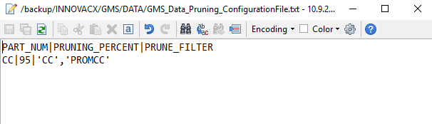

Below table shows the sample filter criteria to update Pruning Configuration file for some Products.

|  |  |
| --- | --- |
| **PART_NUM** | **PRUNE_FILTER** |
| CC | 'CC','PROMCC' |
| PC | 'PC','PROMPC' |
| CB | 'CB','PROMCB' |

As part of the pruning process,

1. Member numbers (Contacts) inserted in the Prune table will be retained
2. System data (User, Employee & Organization) will not be pruned
3. If members are mentioned explicitly in the ‘GMS_MEMBER_NUMBER.txt’ file, then it will not be pruned and masked.
4. All the children table data linked to Contact/Member will be retained for pruning .
5. Looping logic has been implemented to perform pruning on each table.
6. As per number of records per batch in the ‘GMS_TABLE_BATCH_COUNT.txt’ file and number of batches, records will be inserted, EIM job gets executed and EIM table will be truncated to insert next set of records.
7. DB stats and index creation is done on each table before executing EIM delete process.
8. If Validation script (i/p – passing percentage) fails, process will end.

### 5.2 List of tables to be Pruned using Siebel EIM

|  |  |  |
| --- | --- | --- |
| **TABLE NAME** | **CHILD TABLE?** | **CASCADE DELETE** |
| **S_ORDER** | No | Yes |
| S_ORDER_DTL | Yes |
| S_ORDER_FMX | Yes |
| S_ORDER_PC_LSX | Yes |
| S_ORDER_PSX | Yes |
| S_ORDER_TNTX | Yes |
| S_ORDER_X | Yes |
| **S_ORDER_ITEM** | No | Yes |
| S_ORDERITM_TRMS | Yes |
| S_ORDER_ITEM_OM | Yes |
| S_ORDER_ITEM_X | Yes |
| S_ORDER_ITM_PRI | Yes |
| S_ORD_ITM_LOYX | Yes |
| S_ORDERITM_TNTX | Yes |
| S_ORDER_ITEM_XA | Yes |
| **S_EVT_ACT** | No | Yes |
| S_ACT_CONTACT | Yes |
| S_EVT_ACT_X | Yes |
| S_EVT_ACT_FNX | Yes |
| S_EVT_ACT_FSX | Yes |
| S_ENTLMNT | Yes |
| S_AGREE_BNFT | Yes |
| **S_CONTACT** | No | Yes |
| **S_ORG_EXT** | No | Yes |
| **S_ADDR_PER** | No | No |
| **S_ASSET** | No | Yes |
| **S_DOC_QUOTE** | No | Yes |
| **S_DOC_AGREE** | No | Yes |
| **S_SRC_PAYMENT** | No | Yes |
| **S_SRV_REQ** | No | Yes |

### List of tables to be Pruned using truncate

|  |  |
| --- | --- |
| **Table Name** | **Treatment** |
| S_WFA_INST_LOG | TRUNCATE |
| S_WFA_INST_PROP | TRUNCATE |
| S_WFA_INSTP_LOG | TRUNCATE |
| S_WFA_STPRP_LOG | TRUNCATE |
| S_ESCL_LOG | TRUNCATE |
| S_VALDN_INST | TRUNCATE |
| S_SRM_DATA | TRUNCATE |
| S_SRM_REQUEST | TRUNCATE |
| S_ESCL_REQ | TRUNCATE |
| S_AUDIT_ITEM | TRUNCATE |
| CX_CAM_RESPONSE | TRUNCATE |
| CX_IRASLOGREQ_X | TRUNCATE |
| CX_IRAS_LOG | TRUNCATE |
| CX_BULK_UPLOAD | TRUNCATE |
| CX_OMC_PROC | TRUNCATE |
| CX_LOG_ERROR | TRUNCATE |

## Masking

### 6.1 Logic for Masking

Jobs for masking gets executed only when ‘DIDGMSRunMask’ – Jenkins global variable is set to ‘Y’.

If this global variable value is set to ‘N’ then post-tasks gets executed as per condition setup.

As a pre-requisite, below steps should be completed before executing masking job –

1. All the Jenkins global variables & global credentials should be set with the appropriate values (Ref. sections 8.1 & 8.2)
2. For master tables that are getting masked, number of records per batch should be set in the file ‘GMS_TABLE_BATCH_COUNT.txt’ (path: /backup/INNOVACX/DATA)



Note: Tables ending ‘_M’ represents masking

1. IFB files should be placed at appropriate path (ref. GMS Operational guide)
2. Masking configuration file ‘GMS_Data_Masking_ConfigurationFile.txt’ (path: /backup/INNOVACX/DATA) should be updated as per requirement.



1. Update ‘GMS_MEMBER_NUMBER.txt’ file to specify member number explicitly to exclude it from pruning and Masking

As part of masking process,

1. System data (User, Employee & Organization) will not be masked
2. If members are mentioned explicitly in the ‘GMS_MEMBER_NUMBER.txt’ file, then it will not be masked.
3. As per number of records per batch in the ‘GMS_TABLE_BATCH_COUNT.txt’ file and number of batches, records will be inserted and EIM job gets executed
4. DB stats is done on each table before executing EIM update process
5. If Validation script (i/p – passing percentage) fails, process will end

#### 6.1.1 Logic for Non-Date Type Columns

Oracle SQL Translate function is used to mask the values.

|  |  |
| --- | --- |
| **Masking Logic** | |
| **Function used** | **TRANSLATE** |
| **V_STRING_TO_REPLACE** | **abcdefghijklmnopqrstuvwxyzABCDEFGHIJKLMNOPQRSTUVWXYZ0123456789** |
| **V_REPLACEMENT_STRING** | **zabycxdwevfugthsirjqkplonmZABYCXDWEVFUGTHSIRJQKPLONM2014365897** |

E.g. 1:

Actual Value: NB8

Masked Value: TA9

Eg2:

Actual Value: [abc@gmail.com](mailto:abc@gmail.com)

Masked Value: [zab@dgzeu.bhg](mailto:zab@dgzeu.bhg)

#### 6.1.2 Logic for Date Type Columns:

A global parameter ‘DID_Masking_Date_value’ has been created to store the number of days. A numeric value has to be passed to this parameter. The value is treated as ‘No of Days’ and will be subtracted from the values in the Date columns

Eg 1:

DID_Masking_Date_value = 300

Actual Value: 23-OCT-2018

Masked Value: 27-DEC-2017

Eg 2:

DID_Masking_Date_value = 450

Actual Value: 12-JUN-2018

Masked Value: 19-MAR-2017

### List of Attributes to be Masked

|  |  |  |
| --- | --- | --- |
| **TABLE NAME** | **Columns** | **Masking Logic** |
| S_CONTACT | FST_NAME | TRANSLATE(FST_NAME, V_STRING_TO_REPLACE,V_REPLACEMENT_STRING) |
| LAST_NAME | TRANSLATE(LAST_NAME,V_STRING_TO_REPLACE,V_REPLACEMENT_STRING) |
| BIRTH_DT | (CON.BIRTH_DT- <DID_Masking_Date_value>) (Mask date value, will be passed from Jenkins) |
| HOME_PH_NUM | TRANSLATE( HOME_PH_NUM ,V_STRING_TO_REPLACE, V_REPLACEMENT_STRING) |
| MID_NAME | TRANSLATE( MID_NAME ,V_STRING_TO_REPLACE,V_REPLACEMENT_STRING) |
| CELL_PH_NUM | TRANSLATE( CELL_PH_NUM ,V_STRING_TO_REPLACE,V_REPLACEMENT_STRING) |
| ASST_PH_NUM | TRANSLATE( ASST_PH_NUM ,V_STRING_TO_REPLACE,V_REPLACEMENT_STRING) |
| EMAIL_ADDR | TRANSLATE( EMAIL_ADDR ,V_STRING_TO_REPLACE,V_REPLACEMENT_STRING) |
| ALT_EMAIL_ADDR | TRANSLATE( ALT_EMAIL_ADDR ,V_STRING_TO_REPLACE,V_REPLACEMENT_STRING) |
| WORK_PH_NUM | TRANSLATE( WORK_PH_NUM ,V_STRING_TO_REPLACE,V_REPLACEMENT_STRING) |
| FAX_PH_NUM | TRANSLATE( FAX_PH_NUM ,V_STRING_TO_REPLACE,V_REPLACEMENT_STRING) |
| X_DRV_LIC_CLS | TRANSLATE( X_DRV_LIC_CLS ,V_STRING_TO_REPLACE,V_REPLACEMENT_STRING) |
| CSN | TRANSLATE( CSN ,V_STRING_TO_REPLACE,V_REPLACEMENT_STRING) |
| S_CONTACT_X | ATTRIB_43 | TRANSLATE( ATTRIB_43 ,V_STRING_TO_REPLACE,V_REPLACEMENT_STRING) |
| ATTRIB_36 | TRANSLATE( ATTRIB_36 ,V_STRING_TO_REPLACE,V_REPLACEMENT_STRING) |
| ATTRIB_02 | TRANSLATE( ATTRIB_02 ,V_STRING_TO_REPLACE,V_REPLACEMENT_STRING) |
| ATTRIB_41 | TRANSLATE( ATTRIB_41 ,V_STRING_TO_REPLACE,V_REPLACEMENT_STRING) |
| S_CONTACT_ATX | DRIVER_LICENSE | TRANSLATE( DRIVER_LICENSE ,V_STRING_TO_REPLACE,V_REPLACEMENT_STRING) |
| S_ORG_EXT | X_EMAIL_UNSUBCRIBE_DT | (X_EMAIL_UNSUBCRIBE_DT – DID_Masking_Date_value) Mask date value, will be passed from Jenkins |
| MAIN_EMAIL_ADDR | TRANSLATE( MAIN_EMAIL_ADDR ,V_STRING_TO_REPLACE,V_REPLACEMENT_STRING) |
| X_LEGAL_ENTITY_NAME | TRANSLATE( X_LEGAL_ENTITY_NAME ,V_STRING_TO_REPLACE,V_REPLACEMENT_STRING) |
| MAIN_PH_NUM | TRANSLATE( MAIN_PH_NUM ,V_STRING_TO_REPLACE,V_REPLACEMENT_STRING) |
| ANS_SRVC_PH_NUM | TRANSLATE( ANS_SRVC_PH_NUM ,V_STRING_TO_REPLACE,V_REPLACEMENT_STRING) |
| OU_NUM | TRANSLATE(OU_NUM,V_STRING_TO_REPLACE,V_REPLACEMENT_STRING) |
| S_ORG_EXT (UK's) | NAME | TRANSLATE( NAME ,V_STRING_TO_REPLACE,V_REPLACEMENT_STRING) |
| LOC | TRANSLATE( LOC ,V_STRING_TO_REPLACE,V_REPLACEMENT_STRING) |
| S_ORG_EXT_FNX | |  |  | | --- | --- | | BRLOC_ATTRIB01 | BRLOC_ATTRIB01 | | TRANSLATE( BRLOC_ATTRIB01 ,V_STRING_TO_REPLACE,V_REPLACEMENT_STRING) |
| TECH_IMP_CD | TRANSLATE( TECH_IMP_CD ,V_STRING_TO_REPLACE,V_REPLACEMENT_STRING) |
| NPI_NUM | TRANSLATE( NPI_NUM ,V_STRING_TO_REPLACE,V_REPLACEMENT_STRING) |
| S_PTY_PAY_PRFL | ACCNT_BANK_NAME | TRANSLATE( ACCNT_BANK_NAME ,V_STRING_TO_REPLACE,V_REPLACEMENT_STRING) |
| ACCNT_BANK_BRANCH | TRANSLATE( ACCNT_BANK_BRANCH ,V_STRING_TO_REPLACE,V_REPLACEMENT_STRING) |
| DESC_TEXT | TRANSLATE( DESC_TEXT ,V_STRING_TO_REPLACE,V_REPLACEMENT_STRING) |
| X_ACCNT_NAME | TRANSLATE( X_ACCNT_NAME ,V_STRING_TO_REPLACE,V_REPLACEMENT_STRING) |
| PROFILE_NAME | TRANSLATE( PROFILE_NAME ,V_STRING_TO_REPLACE,V_REPLACEMENT_STRING) |
| X_SEC_PAY_TOKEN | TRANSLATE( X_SEC_PAY_TOKEN ,V_STRING_TO_REPLACE,V_REPLACEMENT_STRING) |
| PAY_ACCNT_NUM | TRANSLATE( PAY_ACCNT_NUM ,V_STRING_TO_REPLACE,V_REPLACEMENT_STRING) |
| S_EVT_ACT | CREATOR_LOGIN | TRANSLATE( CREATOR_LOGIN ,V_STRING_TO_REPLACE,V_REPLACEMENT_STRING) |
| X_NEWCONTACT_NAME | TRANSLATE( X_NEWCONTACT_NAME ,V_STRING_TO_REPLACE,V_REPLACEMENT_STRING) |
| CALLER_NAME | TRANSLATE( CALLER_NAME ,V_STRING_TO_REPLACE,V_REPLACEMENT_STRING) |
| X_OLD_MEM_CARD | TRANSLATE( X_OLD_MEM_CARD ,V_STRING_TO_REPLACE,V_REPLACEMENT_STRING) |
| S_EVT_ACT_FNX | TLR_ANONYMS_NAME | TRANSLATE( TLR_ANONYMS_NAME ,V_STRING_TO_REPLACE,V_REPLACEMENT_STRING) |
| EXT_SYS_TXN_IDEN | TRANSLATE( EXT_SYS_TXN_IDEN ,V_STRING_TO_REPLACE,V_REPLACEMENT_STRING) |
| S_SRV_REQ | X_DRIVER_EMAIL | TRANSLATE( X_DRIVER_EMAIL ,V_STRING_TO_REPLACE,V_REPLACEMENT_STRING) |
| X_DRIVER_PHONE | TRANSLATE( X_DRIVER_PHONE ,V_STRING_TO_REPLACE,V_REPLACEMENT_STRING) |
| ALT_CON_EMAIL | TRANSLATE( ALT_CON_EMAIL ,V_STRING_TO_REPLACE,V_REPLACEMENT_STRING) |
| X_ADDR_LINE_2 | TRANSLATE( X_ADDR_LINE_2 ,V_STRING_TO_REPLACE,V_REPLACEMENT_STRING) |
| X_REQUESTOR_FULL_NAME | TRANSLATE( X_REQUESTOR_FULL_NAME ,V_STRING_TO_REPLACE,V_REPLACEMENT_STRING) |
| X_NRMA_REQ_HOME_PHONE | TRANSLATE( X_NRMA_REQ_HOME_PHONE ,V_STRING_TO_REPLACE,V_REPLACEMENT_STRING) |
| X_BSB | TRANSLATE( X_BSB ,V_STRING_TO_REPLACE,V_REPLACEMENT_STRING) |
| X_INTER_CLUB_MEM_NUM | TRANSLATE( X_INTER_CLUB_MEM_NUM ,V_STRING_TO_REPLACE,V_REPLACEMENT_STRING) |
| X_INSTATE_CLUB_NAME | TRANSLATE( X_INSTATE_CLUB_NAME ,V_STRING_TO_REPLACE,V_REPLACEMENT_STRING) |
| X_NRMA_REQ_EMAIL | TRANSLATE( X_NRMA_REQ_EMAIL ,V_STRING_TO_REPLACE,V_REPLACEMENT_STRING) |
| S_SRV_REQ_X | ATTRIB_03  ATTRIB_43 | TRANSLATE( ATTRIB_03 ,V_STRING_TO_REPLACE,V_REPLACEMENT_STRING)  TRANSLATE( ATTRIB_43 ,V_STRING_TO_REPLACE,V_REPLACEMENT_STRING) |
| ATTRIB_42 | TRANSLATE( ATTRIB_42 ,V_STRING_TO_REPLACE,V_REPLACEMENT_STRING) |
| S_ORDER | X_OMC_CAMP_NAME | TRANSLATE( X_OMC_CAMP_NAME ,V_STRING_TO_REPLACE,V_REPLACEMENT_STRING) |
| S_ORDER_X | ATTRIB_39 | TRANSLATE( ATTRIB_39 ,V_STRING_TO_REPLACE,V_REPLACEMENT_STRING) |
| S_SRC | NAME | TRANSLATE( NAME ,V_STRING_TO_REPLACE,V_REPLACEMENT_STRING) |
| S_SRC_PAYMENT | X_EXT_PAY_REF | TRANSLATE( X_EXT_PAY_REF ,V_STRING_TO_REPLACE,V_REPLACEMENT_STRING) |
| S_ADDR_PER | ADDR | TRANSLATE( ADDR ,V_STRING_TO_REPLACE,V_REPLACEMENT_STRING) |
| ADDR_LINE_2 | TRANSLATE( ADDR_LINE_2 ,V_STRING_TO_REPLACE,V_REPLACEMENT_STRING) |
| X_ADDR_ROLE | TRANSLATE( X_ADDR_ROLE ,V_STRING_TO_REPLACE,V_REPLACEMENT_STRING) |
| S_AGREE_BNFT | NAME | TRANSLATE( NAME ,V_STRING_TO_REPLACE,V_REPLACEMENT_STRING) |
| S_ASSET | NAME | TRANSLATE( NAME ,V_STRING_TO_REPLACE,V_REPLACEMENT_STRING) |
| X_TRANS_PHONE | TRANSLATE( X_TRANS_PHONE ,V_STRING_TO_REPLACE,V_REPLACEMENT_STRING) |
| S_ASSET_X | X_NOTIFICATION_EMAIL | TRANSLATE( X_NOTIFICATION_EMAIL ,V_STRING_TO_REPLACE,V_REPLACEMENT_STRING) |
| ATTRIB_37 | TRANSLATE( ATTRIB_37 ,V_STRING_TO_REPLACE,V_REPLACEMENT_STRING) |
| X_VEH_DEPOT_PH | TRANSLATE( X_VEH_DEPOT_PH ,V_STRING_TO_REPLACE,V_REPLACEMENT_STRING) |
| X_AUTH_CON_NAME | TRANSLATE( X_AUTH_CON_NAME ,V_STRING_TO_REPLACE,V_REPLACEMENT_STRING) |
| X_AUTH_CON_PH | TRANSLATE( X_AUTH_CON_PH ,V_STRING_TO_REPLACE,V_REPLACEMENT_STRING) |
| X_AUTH_CON_EMAIL | TRANSLATE( X_AUTH_CON_EMAIL ,V_STRING_TO_REPLACE,V_REPLACEMENT_STRING) |
| X_VEH_WRTY_PH | TRANSLATE( X_VEH_WRTY_PH ,V_STRING_TO_REPLACE,V_REPLACEMENT_STRING) |
| X_ENGINE_WRTY_PH | TRANSLATE( X_ENGINE_WRTY_PH ,V_STRING_TO_REPLACE,V_REPLACEMENT_STRING) |
| X_BAT_WRTY_PH | TRANSLATE( X_BAT_WRTY_PH ,V_STRING_TO_REPLACE,V_REPLACEMENT_STRING) |
| X_GEAR_WRTY_PH | TRANSLATE( X_GEAR_WRTY_PH ,V_STRING_TO_REPLACE,V_REPLACEMENT_STRING) |

## Post-Tasks

Jenkins post-task job gets executed if pruning or masking or both processes gets executed successfully.

As part of this process,

* Consolidated validation report gets generated at /backup/INNOVACX/GMS/DATA/RESULTS (NRMA_PROCESS_VALIDATION_<MMDD>_<time>.csv)
* Drop user, clear temp tables and procedures will be done
* Enable triggers

## Jenkins

### 8.1 Global Parameters

**Note -** Jenkins Admin can only set these values by navigating to below path:

Jenkins -> Mange Jenkins -> Configure System -> Global properties

|  |  |
| --- | --- |
| **Parameter Name** | **Expected Value** |
| DID_GMS_REMOTEKEY | Remote Server Key |
| DID_GMS_REMOTEHOST | Remote Server Name |
| DID_GMS_ORACLE_SID | DB Connect string |
| DID_GMS_CTL_PATH | The path of CTL folder |
| DID_GMS_DATA_PATH | The path of DATA folder |
| DID_GMS_ENV_PROF_PATH | The path of Environment Profile |
| DID_GMS_LOG_PATH | The path of LOG folder |
| DID_GMS_ORACLE_HOME | The path of oracle home |
| DID_GMS_SCRIPT_PATH | The path of SCRIPTS folder |
| DID_GMS_SQL_PATH | The path of SQL folder |
| DID_Masking_Date_value | A numeric value that needs to be used to subtract from DATE type columns as part of masking |
| DIDBatchRangeCount | A numeric value that needs to be used to decide number of batch ranges executed on a single Jenkins node |
| DIDEnterprise | Siebel Enterprise name |
| DIDServerName | Siebel App Server name |
| DIDGateway | Siebel Gateway name |
| DIDGMSRunPreChk | Accepted values – Y (or) N  This flag is used to control pre-task execution. If set to ‘Y’, pre-tasks gets executed. |
| DIDGMSRunPrune | Accepted values – Y (or) N  This flag is used to control pre-task execution. If set to ‘Y’, pre-tasks gets executed. |
| DIDGMSRunMask | Accepted values – Y (or) N  This flag is used to control pre-task execution. If set to ‘Y’, pre-tasks gets executed. |
| DIDIfbPath | Folder should be created at <siebsrvr>/admin/<new folder> to place the DID IFB files. The new folder name should be mentioned here. |

### 8.2 Global Credentials

**Note -** Jenkins Admin can only set these values by navigating to below path:

Jenkins -> Credentials -> System -> Global credentials (unrestricted) -> Add Credentials

|  |  |  |  |  |
| --- | --- | --- | --- | --- |
| **Kind** | **Scope** | **User Name** | **Password** | **ID** |
| Username with password | Global (Jenkins, nodes, items, all child items, etc.) | NRMADID | NRMADID | DIDDBUser |
| Username with password | Global (Jenkins, nodes, items, all child items, etc.) | <DB Admin> | <DB Admin Password> | DIDDBAdminUser |
| Username with password | Global (Jenkins, nodes, items, all child items, etc.) | <OS User> | <OS User Password> | DIDAdmin |